**Ideation Phase**

**Empathize & Discover**

| Date | 30/10/2025 |
| --- | --- |
| Team ID | NM2025TMID01257 |
| Project Name | Calculating Family Expenses using ServiceNow |
| Maximum Marks | 4 Marks |

**Empathy Map Canvas:**

The Empathy Map Canvas helps in understanding the emotions, behaviors, and challenges of users who manage their family finances.  
For this project Calculating Family Expenses Using ServiceNow the empathy map focuses on how individuals and families think, feel, say, and act when dealing with expenses.  
By gaining a deeper understanding of user needs, we can design a ServiceNow-based solution that simplifies expense tracking, promotes collaboration among family members, and provides real-time insights into financial habits.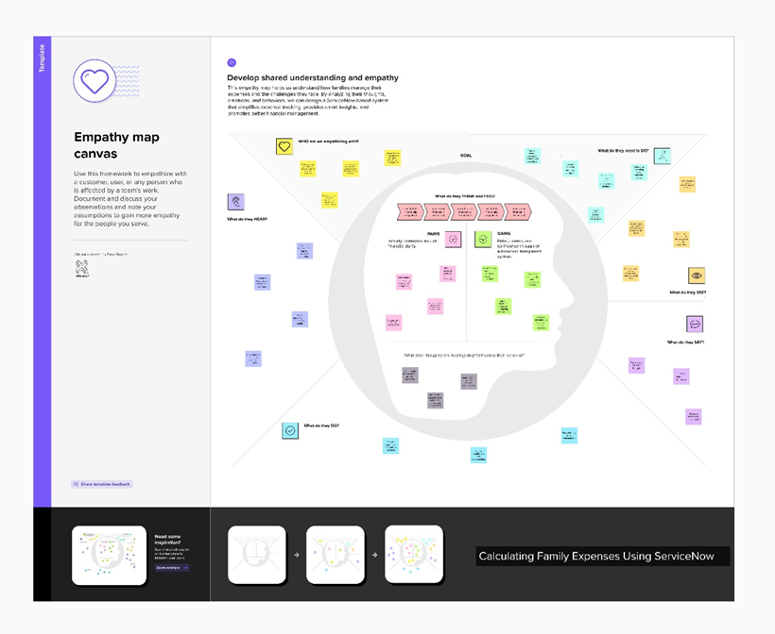

**Example:**

**Example: Family Expense Tracking System Using ServiceNow**

